DAX Measures
NexusMart Data Analytics | CodeConnect’26
Implementation status. A complete dashboard could not be finished within the available time. Instead, work began on the Power BI semantic model and core DAX measures aligned with the metric definitions in the project brief. The screenshots below are preserved as captured implementation evidence.
Validation note. The formulas shown document the measures created during development; they should not automatically be treated as fully validated final metrics. Filter logic, denominator choices, rejected-return handling, and reconciliation against SQL totals should be checked before use in a finished report.

Metric definitions and DAX implementation evidence
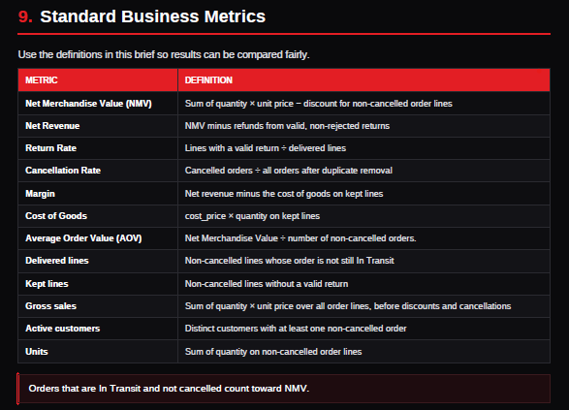

Active customers
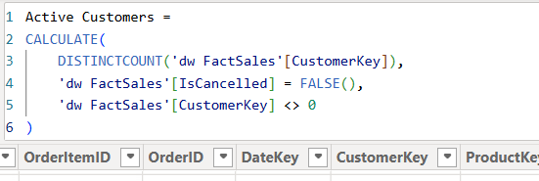

Cancellation Rate
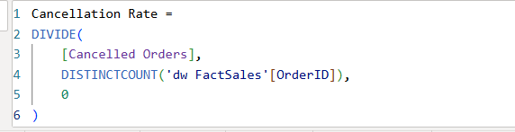

Cancelled Orders

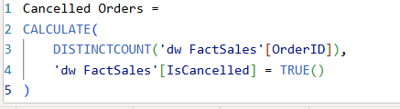

COGS
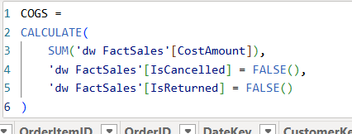

Delivered Lines
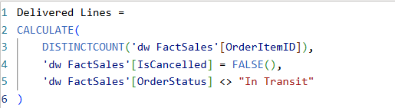

Gross Sales
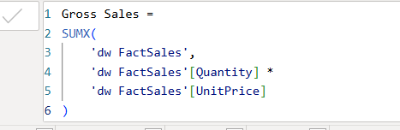

Margin Amount
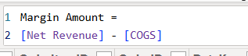

Net Revenue
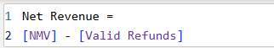

Orders
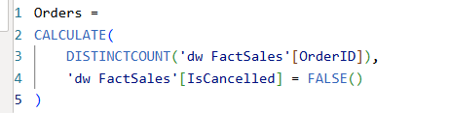

Return Date
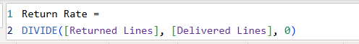

Returned Line
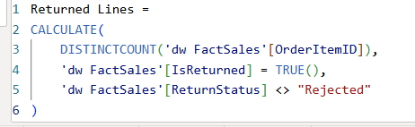

Total discount
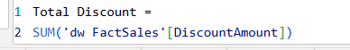

NMV
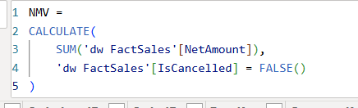

Units Sold
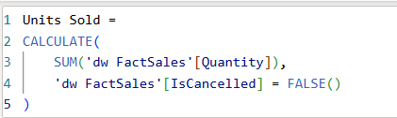

Valid Refunds
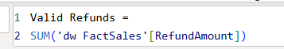

Next validation steps
• Reconcile NMV, net revenue, refunds, COGS, and margin against SQL warehouse totals.
• Confirm return rate uses valid-return lines divided by delivered lines, as required.
• Validate cancellation rate using distinct cancelled orders divided by all orders after duplicate removal.
• Confirm valid refunds exclude rejected returns where required, and review unknown dimension members.
• Use measures in report visuals only after their definitions and totals have been checked.

